

OOP Lab-03 Tasks

Name: Syed Muhammad Raza Ali

Enrolment: 02-134231-028

Course: OOP Lab

Faculty: Miss Hafsa Munawar

Exercises

Exercise 1 *(StringParser.java)*

Write a java program that have this string “Hello! I am string in java. I have several function and I am very “Important”# string_is _importnat” and split it as follows.

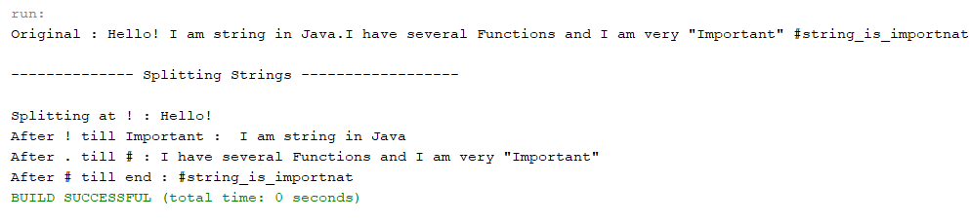

Code:

package com.mycompany.mavenproject2;

import java.util.Scanner;

class Tasks{

//Task---01

public void Task1(){

String myStr = "Hello! I am a String in java. I have several functions and I am very 'important' #String_is_important";

System.out.println("-------------- Spliting Strings -------------- ");

System.out.println(myStr);

System.out.println("Spliting at ! :"+myStr.substring(0,myStr.indexOf("!")+1));

System.out.println("Splitting from ! to Important : "+myStr.substring( (myStr.indexOf("!")+1),

(myStr.lastIndexOf("'")+1)));

System.out.println("Splitting from Important to # : "+myStr.substring((myStr.lastIndexOf("'")+1)

,myStr.lastIndexOf("t")+1) );

}

}

public class Mavenproject2 {

public static void main(String[] args) {

Tasks taskObj = new Tasks();

taskObj.Task1();

}

}

Output:

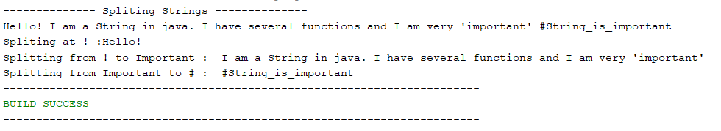

Exercise 2 *(Weekdays.java)*

 Write a Java program that keeps a number from the user and generates an integer between 1 and 7 and displays the name of the weekday as follows.

Code:

package com.mycompany.mavenproject2;

import java.util.Scanner;

class Tasks{

public void Task2(){

Scanner sc = new Scanner(System.in);

System.out.println("Enter a number between 1 to 7 : ");

int day = sc.nextInt();

if(day == 1)

System.out.println("It is sunday");

else if(day == 2)

System.out.println("It is Monday");

else if(day == 3)

System.out.println("It is Tuesday");

else if(day == 4)

System.out.println("It is Wednesday");

else if(day == 5)

System.out.println("It it Thursday");

else if(day == 6)

System.out.println("It is Friday");

else if(day == 7)

System.out.println("It ts Saturday");

else

System.out.println("Invalid Input!!");

}

}

public class Mavenproject2 {

public static void main(String[] args) {

Tasks taskObj = new Tasks();

taskObj.Task2();

}

}

Output:

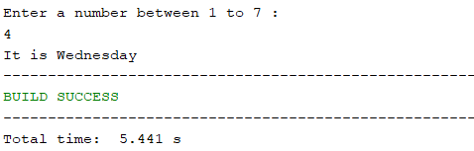

Exercise 3 *(Alphabets.java)*

Write a Java program that takes the user to provide a single character from the alphabet. Print Vowel or Consonant, depending on the user input. If the user input is not a letter (between a & z or A & Z), or is a string of length > 1, print an error message.

Code:

package com.mycompany.mavenproject2;

import java.util.Scanner;

class Tasks{

public void Task3(){

Scanner sc = new Scanner(System.in);

System.out.println("Enter an alphabet : ");

String alphabet = sc.nextLine();

char myChar = alphabet.charAt(0);

if(myChar == 'a' ||myChar == 'A' || myChar == 'e' || myChar == 'E' || myChar == 'i' || myChar == 'I' || myChar == 'o' ||

myChar == 'O' ||myChar == 'u' ||myChar == 'U'){

System.out.println(myChar+" is a Vowel");

}

else{

System.out.println(myChar+" is a consonant");

}

}

public class Mavenproject2 {

public static void main(String[] args) {

Tasks taskObj = new Tasks();

taskObj.Task3();

}

}

Output:

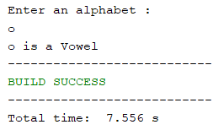

Exercise 4 *(Occurrances.java)*

Write a java program that gets input from a user into an array (size defined by user) then find the max and min numbers found in array as well as the index at which they are found at. Then calculate the difference between two values and the difference between indexes as well. See screen shot for reference. HINT: use java.lang.Math.abspackage to print absolute value between index differences to avoid negative value.

Code:

package com.mycompany.mavenproject2;

import java.util.Scanner;

class Tasks{

//Task---04

public void Task4(){

int size = 0;

Scanner sc = new Scanner(System.in);

System.out.println("Enter the size of Array: ");

size = sc.nextInt();

int[] arr = new int[size];

//arr input

for(int i =0;i<size;i++){

System.out.println("Enter the value of index of: "+i);

arr[i] =sc.nextInt();

}

//arr output

for(int i = 0;i<size;i++){

System.out.println("The value ofindex no "+i+" is "+arr[i]);

}

int maxNumber = arr[0];

int minNumber = arr[0];

int indexOfMin = 0;

int indexOfMax = 0;

//for maxNumber

for(int i = 0;i<size;i++){

if(arr[i]>maxNumber){

maxNumber = arr[i];

indexOfMax =i;

}

}

//for minNumber

for(int i = 0;i<size;i++){

if(arr[i]<minNumber){

minNumber = arr[i];

indexOfMin =i;

}

}

System.out.println("Size of Array : "+size);

System.out.println("Max value of array : "+maxNumber);

System.out.println("Index of Max value : "+indexOfMax);

System.out.println("Min value of array : "+minNumber);

System.out.println("Index of Min value : "+indexOfMin);

}

}

public class Mavenproject2 {

public static void main(String[] args) {

Tasks taskObj = new Tasks();

taskObj.Task4();

}

}

Output:

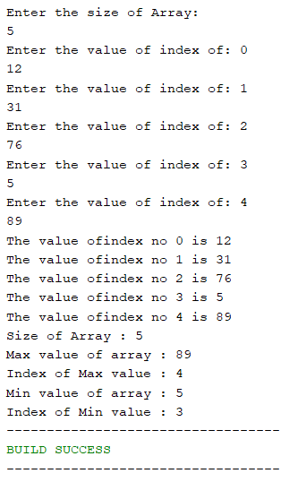

Exercise 6 *(StringReplacement.java)*

Write a Java program to replace each substring of a given string that matches the given regular expression with the given replacement.

Sample string: "this is the sample exercise of OOP basics."

Replace OOP withn ICT.

Code:

package com.mycompany.mavenproject2;

import java.util.Scanner;

class Tasks{

//Task ---06

public void Task6(){

String myStr = "This is the exercise of OOP basics";

System.out.println("String before replacing : ");

System.out.println(myStr);

System.out.println("String after replacing : ");

String newStr = myStr.replace("OOP", "IICT");

System.out.println(newStr);

}

}

public class Mavenproject2 {

public static void main(String[] args) {

Tasks taskObj = new Tasks();

taskObj.Task6();

}

}

Output:

